
9
SPEAR

Surveying and Planning through Electronic Applications and Referrals



SPEAR Release Notes

Release 5.20

The following functional changes to SPEAR have been included in Release 5.20:
 | Users Impacted | Feature | Description
 | Lodging parties, applicant contacts, Land Use Victoria | Improve SPEAR electronic lodgements  - CR 5978 | The following enhancements have been made to SPEAR electronic lodgements:  - Lodging parties will now choose the applicant address from a list of validated, Australian physical addresses. SPEAR will provide options for selection once the first few characters of an address have been entered. Lodging parties can still manually enter an address if a match cannot be found or the applicant lives overseas.  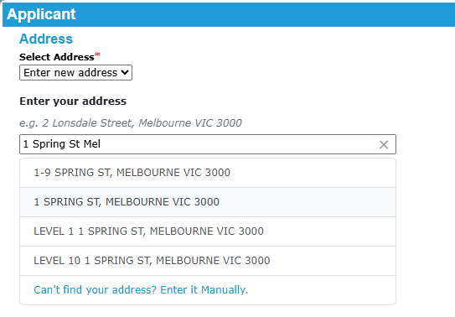  Note: This change also applies to applicant contacts lodging Boundary Plan and Road Alignment applications.  - When determining whether an application accompanied by an ePlan is eligible for the streamlined pre-lodgement check process, SPEAR now applies the following additional lodgement validations:  - All applicant addresses must be valid, physical addresses entered using the new address functionality described above.  - The land specified on the Application Lodgement Form by the lodging party must match the ePlan data.  If the application does not satisfy these criteria, or any of the existing validations, the manual pre-lodgement check process will apply.  - Only lodging party organisations that are configured to represent themselves will be able to sign with two points of certification. This includes government departments and local government authorities.  Subscribers that represent others will no longer see the option to represent themselves and will sign with four points of certification by default.
 | Lodging parties, Land Use Victoria | Improvements to Section 23 easement and restriction applications  - CR 5151-3 | Land Use Victoria has standardised the Application Lodgement Forms for the creation, variation or removal of an easement or restriction under Section 23 of the Subdivision Act 1988:  - All Section 23 dealings are now lodged on the ‘Application to request action by the Registrar’ form.  Note: Lodging parties that have created an Application Lodgement Form for a Section 23 dealing which is not yet lodged will be prompted to change to the new form prior to lodgement. There is no impact to Section 23 dealings that are already lodged.  - The list of available actions on the Application Lodgement Form for a Section 23 dealing was previously limited to easements and has now been expanded to include restrictions.  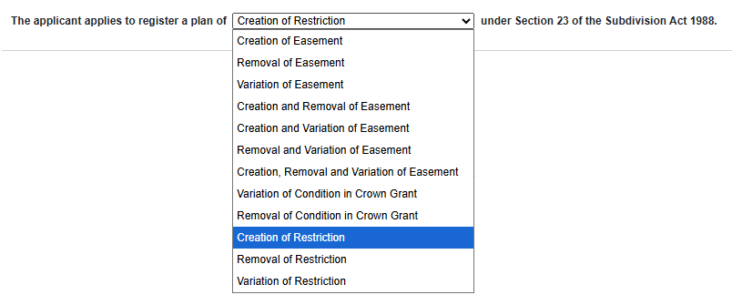
 | Applicant contacts, Land Use Victoria | Rename ‘Office of Surveyor-General Victoria’  - CR 5850 | References to the former “Office of Surveyor-General Victoria” and “OSGV” have been removed or replaced with updated references to “Surveyor-General Victoria” or “SGV”, throughout SPEAR.

